
Republic of Iraq
Ministry of Higher Education and Scientific Research
Scientific Supervision and Evaluation Authority
Department of Quality Assurance and Academic Accreditation
Accreditation Section

Academic Program and Course Description Guide

For an academic program

Al Imam Al Adham University College

Jurisprudence and its Principles Department / Nineveh

For the academic year
2025-2026

Introduction:
An educational program is a coordinated and organized package of academic courses comprising procedures and experiences structured as curricula. Its primary purpose is to build and refine graduates' skills, ensuring they are qualified to meet labor market requirements. These programs undergo annual review and evaluation through internal and external auditing procedures, such as the External Examiner Program.
The Academic Program Description provides a concise summary of the program's key features and courses, highlighting the skills intended for students based on the program’s objectives. This description is vital as it serves as the cornerstone for obtaining program accreditation; it is collaboratively drafted by the teaching staff under the supervision of scientific committees within the academic departments.
This second edition of the manual includes the academic program description following the update of the previous manual's components and sections. These updates reflect the latest developments in the Iraqi educational system, covering the traditional academic program description (annual and semester systems). Furthermore, it incorporates the generalized academic program description mandated by the Department of Studies' letter (TM3/2906 on May 3, 2023) regarding programs adopting the Bologna Process as their operational basis.
In this context, we emphasize the significance of drafting academic program and course descriptions to ensure the effective progression of the educational process.

- (Academic Program Description):
Provides a brief summary of the program's vision, mission, and objectives, including an accurate description of the targeted learning outcomes based on specific learning strategies.
- (Course Description):
Provides a concise summary of the most important characteristics of the course and the learning outcomes expected of the student, demonstrating the maximum benefit gained from the available learning opportunities. It is derived from the program description.
- (Program Vision):
An ambitious image of the academic program's future to be a developed, inspiring, motivating, realistic, and applicable program.
- (Program Mission):
Briefly clarifies the objectives and activities necessary to achieve them, and defines the program's development paths and directions.
- (Program Objectives):
Statements describing what the academic program intends to achieve within a specific period; they must be measurable and observable.
- (Curriculum Structure):
All courses/subjects included in the academic program according to the adopted learning system (semester, annual, Bologna Process), whether they are requirements (Ministry, University, College, or Department) along with the number of credit units.
- (Learning Outcomes):
A consistent set of knowledge, skills, and values acquired by the student after successfully completing the academic program. Learning outcomes for each course must be defined in a way that achieves the program's overall objectives.
- (Teaching and Learning Strategies):
Strategies used by the faculty member to develop student learning; they are plans followed to reach learning goals, describing all classroom and extra-curricular activities to achieve the program's learning outcomes.

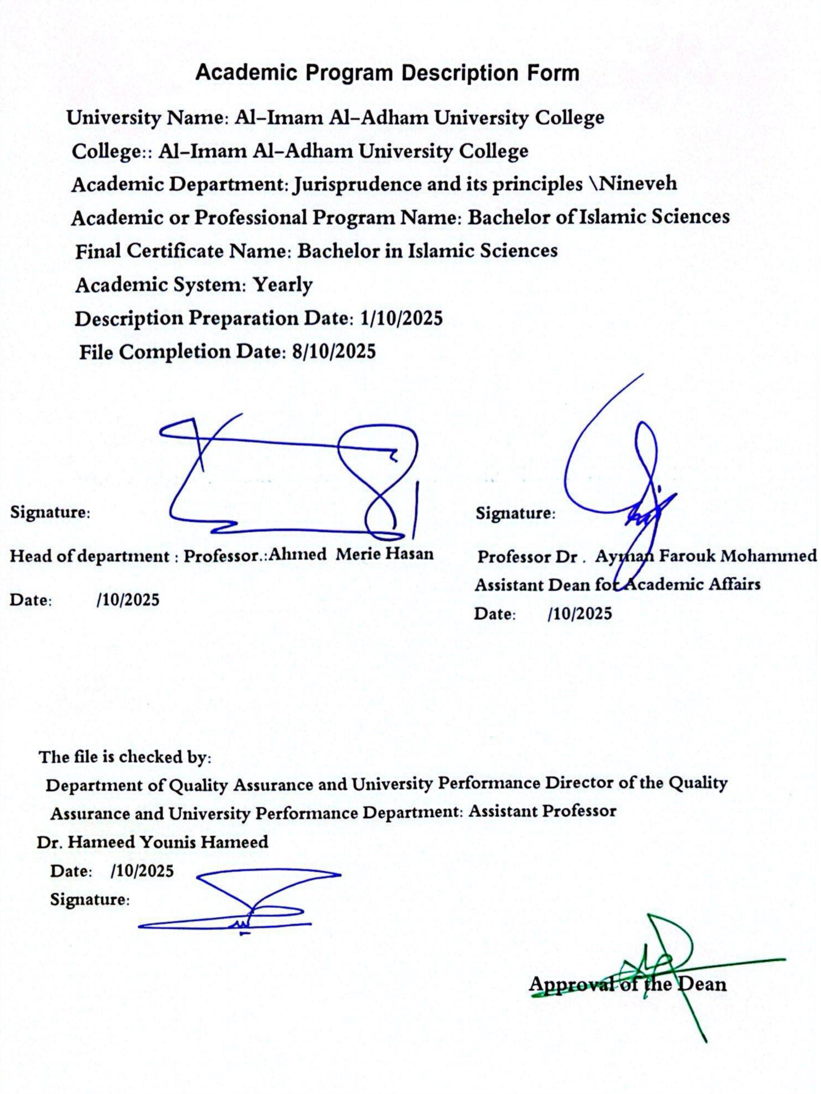
- Program Vision
The department's vision is reflected in its work on developing a strategy that addresses the following :
First: Teaching students Islamic sciences and focusing on the science of jurisprudence and its principles, while also paying attention to intellectual, legal and educational sciences.
Second: Working to understand the jurisprudence of disagreement and its impact on spreading a culture of tolerance, containing the dissenter, and recognizing rights and duties in accordance with general Sharia principles, in light of a charged global atmosphere that prevents listening to the rich and diverse ideas that others are supposed to understand, without necessarily adopting them.
Third: Demonstrating the values of moderation and balance in dealing with others in accordance with the rules set forth by Islamic law, which is the standard by which dealings can be conducted.

- Program message
1- Demonstrating the ease of Islamic legal rulings through the study of jurisprudence and its principles, through which the flexibility and authenticity of Islamic legislation become apparent.
2- Training specialized personnel to teach subjects related to Sharia sciences (jurisprudence and its principles).
3- Seeking to communicate with other scientific and cultural communities by holding conferences, seminars and scientific workshops in a modern style , electronically or in person.
4- Realizing the greatness of this religion and that it is suitable for all times and places and that it came to achieve the interests of people within the general objectives of Sharia.
5- Explaining the role of the Department of Jurisprudence and its Principles in finding solutions to the problems that society is going through.
6- Linking the present of the Islamic nation to its past by venerating the religious texts.

- Program Objectives
- The call for tolerance, and the establishment of values of difference and respect for others.
2- Spreading a culture of peaceful and communal coexistence, establishing rules for dialogue, and avoiding anything that could harm the national unity of society.
3- Establishing a critical, dialogical mindset, overcoming a closed , static mindset , and addressing the causes of disagreement.
4- Understanding contemporary issues and explaining their jurisprudential rulings in accordance with Sharia principles.
5- Emphasizing the correct understanding of religion in light of a moderate approach, and moving away from fanatical and aggressive statements, ideas and positions.
6- Revealing the positive impact of a correct understanding of Islamic jurisprudence and its effect on sustainable development.
7- Providing society with specialized scientific personnel in the field of issuing fatwas.
8- Clarifying the enlightening rational, ethical, human, aesthetic and moral dimensions of jurisprudence and its principles.
9- Education on respecting freedoms and human rights, and every thing that enhances human dignity, as it is one of the foundations of Sharia and its rulings .

- Program accreditation
Work is underway on it

- Other external influences
Ministry of Higher Education and Scientific Research / Scientific Cooperation Agreements with the University of Anbar , Mosul and Diyala / Application and observation with the Ministry of Education and the Department of Religious Education and Islamic Studies .

- Program structure
Program structure | Number of courses | Study unit | Percentage | comments
Institutional requirements | 6 | 12 | 20% | Core course
College requirements | 20 | 40 | 20%
Department requirements | 46 | 155 | 60%
Summer training |  |  |  | nothing
practical application | A collaborative application with the Ministry of Education and the Department of Religious Education in schools
* The notes may include whether the course is core or elective . .
7- Program Description : Curriculum for the primary stages, Department of Jurisprudence and its Principles, for the year 2025-2026 |  |  |  |  |  |  |  |  | Units and credit hours
Academic stage |  |  | Course code |  | Course name | Credit hours and units |  |  | Units and credit hours
First stage  Course code |  |  |  |  |  | theoretical | practical |  | Bachelor's degree  ( 155 ) credit hours are required
First | TIF100 |  |  |  | Interpretation of the verses of rulings | 2 |  |  | 20
First | FiK100 |  |  |  | Jurisprudence | 3 |  |  | 20
First | ISS107 |  |  |  | Principles of Islamic Jurisprudence | 3 |  |  | 20
First | NAH100 |  |  |  | Grammar and Morphology | 3 |  |  | 20
First | HAR104 |  |  |  | Freedom, human rights, and democracy | 3 |  |  | 20
First | ENC140 |  |  |  | English language | 1 |  |  | 20
First | HAS103 |  |  |  | Calculator | 1 |  |  | 20
First | HAF105 |  |  |  | Memorizing the Quran  and the rules of Tajweed | 2 |  |  | 20
First | NiF103 |  |  |  | Educational Psychology | 1 |  |  | 20
First | MiD301 |  |  |  | Introduction to Sharia | 2 |  |  | 20
the total |  |  |  |  |  | 20  hour  36 credit hours | the total |  | 20
Phase Two Course Code
Second |  | TIF102 |  |  | Interpretation of the verses of rulings | 2 |  |  | 24
Second |  | FiK101 |  |  | Jurisprudence | 3 |  |  | 24
Second |  | ISS108 |  |  | Principles of Islamic Jurisprudence | 2 |  |  | 24
Second |  | NAH412 |  |  | Grammar and Morphology | 3 |  |  | 24
Second |  | MOC103 |  |  | Hadith terminology and Hadith preservation | 2 |  |  | 24
Second |  | AKL301 |  |  | Islamic ethics | 1 |  |  | 24
Second |  | MAN308 |  |  | logic | 2 |  |  | 24
Second |  | HAF307 |  |  | Memorizing the Quran and the rules of Tajweed | 2 |  |  | 24
Second |  | ENC311 |  |  | English language | 1 |  |  | 24
Second |  | HASS312 |  |  | Calculator | 1 |  |  | 24
Second |  | SEE310 |  |  | The Prophet's Biography | 2 |  |  | 24
Second |  | CAS305 |  |  | Sharia policy | 2 |  |  | 24
Second |  |  |  |  | Baathist crimes | 1 |  |  | 24
the total |  |  |  |  |  | 24 hours  44 units |  | the total | 24
Phase Three Course Code
Third |  | FIK103 |  |  | Jurisprudence | 4 |  |  | 24
Third |  | ISS109 |  |  | Principles of Islamic Jurisprudence | 3 |  |  | 24
Third |  | NAH413 |  |  | Grammar | 3 |  |  | 24
Third |  | AKE100 |  |  | Islamic doctrine | 2 |  |  | 24
Third |  | HAF308 |  |  | Memorizing the Holy Quran | 1 |  |  | 24
Third |  | AKI308 |  |  | Islamic Economics | 1 |  |  | 24
Third |  | MOA304 |  |  | Financial transactions | 1 |  |  | 24
Third |  | BLA316 |  |  | Rhetoric | 2 |  |  | 24
Third |  | TAR309 |  |  | Teaching methods | 2 |  |  | 24
Third |  | MAN300 |  |  | Research Methodology | 2 |  |  | 24
Third |  | NOT412 |  |  | Islamic systems | 1 |  |  | 24
Third |  |  |  |  | Biography of the Prophet's Family | 1 |  |  | 24
Third |  | ADB300 |  |  | Etiquette of research and debate | 1 |  |  | 24
the total |  |  |  |  |  | 24 hours  41 credit hours |  | the total | 24
Phase Four Course Code
Fourth |  | MAK100 |  |  | Objectives of Islamic Law | 2 |  |  | 22
Fourth |  | FiK104 |  |  | Comparative jurisprudence | 3 |  |  | 22
Fourth |  | ISS110 |  |  | Principles of Islamic Jurisprudence | 3 |  |  | 22
Fourth |  | NAH414 |  |  | Grammar | 2 |  |  | 22
Fourth |  | HAF409 |  |  | Memorizing the Quran | 1 |  |  | 22
Fourth |  | KWA400 |  |  | legal principles | 2 |  |  | 22
Fourth |  | AHD401 |  |  | Hadiths on rulings | 2 |  |  | 22
Fourth |  | MSH410 |  |  | Research project | 1 |  |  | 22
Fourth |  | KES416 |  |  | Measurement and Evaluation | 2 |  |  | 22
Fourth |  | MSH413 |  |  | Viewing and applying | 4 |  |  | 22
the total |  |  |  |  |  | 22 hours  34 credit hours |  | the total

8. Expected learning outcomes of the program
Knowledge
Learning Outcomes 1  A1. The student should become familiar with the concepts and foundations of the science of jurisprudence and its principles.  A2. To be able to classify jurists according to their methodologies.  A3. To be able to adopt systematic thinking methods that are appropriate to the form and content of knowledge available in jurisprudential and scientific sources.  A4. To be able to memorize the principles and rules of the rulings . | Statement of Learning Outcomes 1  - The ability to define the concepts of jurisprudence and its principles.  - The ability to describe the methodologies of jurists objectively.  - Knowledge of the jurisprudential sources for the science of jurisprudence and its principles.  - Developing the ability to memorize scientific principles and legal rules.
Skills
Learning Outcomes 2  B1. The student should be able to analyze Qur’anic texts and deduce legal rulings.  B2. To be able to compare the approaches of jurists and points of disagreement in order to reach solutions to problems Using a variety of sources and drawing sound conclusions , in accordance with established principles and rules of Islamic law.  B3. Developing a moderate, balanced approach to addressing jurisprudential issues Contemporary engagement through dialogue with others.  B4. The student should be able to adopt scientific thinking methods in confronting problems and extremist thought. | Statement of Learning Outcomes 2  - Developing the ability to analyze and draw conclusions from judgments  - Enhancing scientific research writing skills and becoming familiar with the most important ancient and modern sources in the field of jurisprudence and its principles.  - Applying the methods involved in critical thinking and creative problem-solving .  - Using communication techniques to understand intellectual diversity in societies
Values
Learning Outcomes 3  A1. Introducing the student to the importance of the Holy Quran and that it is the constitution of Muslims and the primary source of legislation.  Part 2. To adhere to professional ethics in carrying out his educational duties, scientific research, and ethics.  A3. To be able to spread a culture of peace and moderation derived from the Holy Quran.  Q4. The ability to analyze Qur’anic texts, try to understand their depths, and benefit from the legal rulings in public and practical life. | Statement of Learning Outcomes 3  - Preserving Islamic customs, values, and Islamic identity.  - Acting ethically and adhering to high moral values on a personal and social level .  - Creative thinking in dealing with multiple cultures.  - Instilling the spirit of Islam in the student by encouraging him to read the Holy Quran and uncover its secrets and miracles .

9. Teaching and learning strategies
Targeted learning outcomes are developed through activities and strategies. The following teaching method :
First, teaching strategies:
- The strategy of lecturing or giving a presentation.
- Discussion strategy .
- Problem-solving strategy.
- Project-based learning strategy.
- Cooperative learning strategy .
- Brainstorming strategy .
- Exploration-based learning ( research and inquiry ).
- E-learning.
Secondly, learning strategies:
- Spaced practice.
- Studying.
- Conclusion.
- Switching between ideas.
- Provide examples.
- Dual encoding.
Thirdly, the policies followed in the course:
- Attendance and absence policy .
- Absence from exams
- Submitting assignments on time .
- Safety and prevention measures Health, vaccination against epidemics.
- Cheating and disrupting the classroom are punishable under the Student Discipline Code.
- Giving grades .
The services available at the college that contribute to the study of the subject ( the central library in the college - the graduate studies library)

10. Assessment Methods
- Oral, daily, and monthly tests.
- Research and reports.
- The ability to discuss, analyze, and answer.
- Intellectual questions.
- Discussion sessions led by students .

11. Faculty​
 | Faculty members
Teaching name |  | Scientific rank | Specialization |  | Requirements/  Special skills  (If found) |  | Faculty preparation
 |  | Scientific rank | general | private |  |  | angel | lecturer
Ahmed marey hasan |  | Mr | Jurisprudence and its principles | Principles of Islamic Jurisprudence |  |  | angel | Nothing
Edrees omar mohammed |  | Mr | Jurisprudence and its principles | Jurisprudence |  |  | angel | Nothing
Anas yaseen ebrahim |  | Mr | Islamic Sciences | Jurisprudence |  |  | angel | Nothing
Kahtan mahbob fadhel |  | Mr | Jurisprudence and its principles | Principles of Islamic Jurisprudence |  |  | angel | Nothing
Ahmed shaker mahmood |  | Mr | Fundamentals of Religion | Jurisprudence |  |  | angel | Nothing
Ahmed ensayef jasim |  | Mr | Jurisprudence and its principles | Jurisprudence |  |  | angel | Nothing
Abd al muhsin taha younes |  | Mr | Fundamentals of Religion | Jurisprudence |  |  | angel | Nothing
Emad mohammed ali |  | assistant professor | Jurisprudence and its principles | Principles of Islamic Jurisprudence |  |  | angel | Nothing
Othman moafaq ahmed |  | assistant professor | Invitation and sermon | Islamic thought |  |  | angel | Nothing
yosuf mohammed ali |  | assistant professor | Jurisprudence and its principles | Principles of Islamic Jurisprudence |  |  | angel | Nothing
Ahmed hashem mohammed |  | Mr | Islamic history | History of men |  |  | angel | Nothing
Nasrat hashem mohmmed |  | Mr | Islamic Sciences | Hadith |  |  | angel | Nothing
Meshel abdullah ali |  | Teacher | Islamic Sciences | Doctrine |  |  | angel | Nothing
Satar mohammed abbas |  | Teacher | Islamic Sciences | Hadith |  |  | angel | Nothing
Mohammed abed ali |  | Teacher | Physical education | Teaching methods

Professional Development
Orienting new faculty members
- Introducing new faculty members to the college's vision, mission, goals, organizational structure, policies and procedures.
- To enable new faculty members to gain a better understanding of their rights and obligations.
- Providing new faculty members with detailed information about the college's facilities and services.
- Encouraging new faculty members to participate in seminars and development workshops .
- He urged new faculty members to participate in local and international conferences .
- Encouraging them to publish scientific research in peer-reviewed journals .
Professional development of faculty members
- He urged faculty members to participate in seminars and development workshops in the administrative and scientific fields.
- Working to publish outstanding scientific research by fourth-year students in order to push the scientific movement in the right direction.
- Encouraging the creation of books that include the course syllabi agreed upon by the scientific committees.
- Paying attention to the extent of adherence to the specified time for submitting assignments.
- Writing periodic research papers within the specific area of specialization and discussing them within the department's plan.
- Encouraging faculty members to participate in local and international seminars, workshops and scientific conferences.
12. Admission Criteria
- Adopting admission requirements for students in accordance with the regulations of the Ministry of Higher Education and Scientific Research ( through the central private admission channel and direct admission to the college and department ).
- To successfully pass a special test or personal interview deemed appropriate by the college or department council.
- To be well-suited for the specialization he/she is applying for.
- The learner must have obtained a preparatory school certificate (scientific, literary, Islamic or vocational).
- The capacity of the scientific department.
13. Key sources of information about the program
- Academic websites (scientific researcher)
- Books on jurisprudence and its principles.
- Iraqi Digital Repository for Theses and Dissertations
- Website of Iraqi peer-reviewed journals.
14. Program Development Plan
development plan for faculty members It includes:
- Contributing to the development of the teaching staff's efficiency in the department in a manner that is consistent with the development of Islamic sciences and keeps pace with the development of contemporary sciences.
- The professional development programs are diverse, including seminars and workshops, to impart administrative and scientific skills.
Teaching and learning strategies:
- Adopting modern teaching and learning strategies in the field of specialization. Regularly reviewing the curriculum content.
- Diversifying teaching and learning strategies to achieve the greatest number of outcomes.
Assessing the targeted learning outcomes:
- Prepare a plan of the learning outcomes required by the program .
- Work on measuring and continuously reviewing the achievement of the targeted learning outcomes.
- Utilizing beneficiary surveys to achieve continuous improvement steps.

Program Skills Plan
Learning outcomes required from the program
Year / Level | Course code | Course Name | Essential or optional | Knowledge |  |  |  | Skills |  |  |  | Values
 |  |  |  | A1 | A2 | A3 | A4 | B1 | B2 | B3 | B4 | Part 1 | Part 2 | Part 3 | Q4
the first | FiK100 | jurisprudence | essential | * |  |  |  |  | * |  |  | *
the first | ISS107 | Principles of Islamic Jurisprudence | essential | * |  |  |  |  | * |  |  | *
the second | FiK101 | jurisprudence | essential | * |  |  |  | * |  |  |  | *
the second | ISS108 | Principles of Islamic Jurisprudence | essential | * |  |  |  | * |  |  |  | *
the third | FIK103 | jurisprudence | essential | * |  |  |  | * |  |  |  | *
the third | ISS109 | Principles of Islamic Jurisprudence | essential | * |  |  |  | * |  |  |  | *
Fourth | FiK104 | Comparative jurisprudence | essential | * |  |  |  | * |  |  |  | *
Fourth | ISS110 | Principles of Islamic Jurisprudence | essential | * |  |  |  | * |  |  |  | *

- Please check the boxes corresponding to the individual learning outcomes from the program that are being assessed.

